File permissions in Linux
Check File Permisions
The following code demonstrates how I used Linux commands to checked file permissions set for a specific directory in the file system.
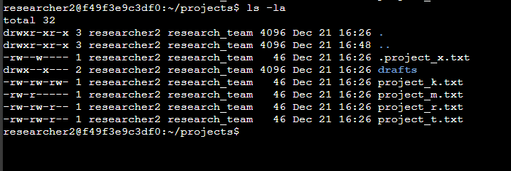

The first line of the screenshot shows the command I entered and the other lines show the output. The code lists all contents including the hidden content in the project in the projects directory. I did this by using the ls command with the option –la option to show a detailed list of the file contents. The output of the commands show one directory named drafts, one hidden file named .projects_x.txt and five other project files. The 10 character strings represent the permissions set of each file in the directory.

Permission Strings
The 10-character string can be deconstructed to determine who is authorised to access the file and their specific permissions. The characters and what they mean are as follows:
- 1st character: This character is either a d or a hyphen (-) and indicates the file type. If it’s a d, it’s a directory and if it’s a hyphen (-), it’s a regular file.
- 2nd-4th characters: These characters show the read (r), write (w), and execute (x) permissions for the user. When one of these characters is a hyphen (-) instead, it indicates that this permission is not granted to the user.
- 5th-7th characters: These characters indicate the read (r), write (w) and execute (x) permissions for the group. When one of these characters is a hyphen (-) instead, it indicates that this permission is not granted for the group.
- 8th-10th characters: These characters indicate the read (r), write (w), and execute (x) permissions for other. This owner type consists of all other users on the system apart from the user and the group. When one of these characters is a hyphen (-) instead, that indicates that this permission is not granted for other.
An example of this would be the file permissions for project_t.txt are –rw-rw-r. Since the first character is a hyphen it indicates that project _t.txt is a file not a directory. The 2nd, 5th and 8th characters are all (r) which indicates that user, group and other all have read permissions. The 3rd and 6th characters are (w) which indicates that only the user and group have write permissions. No one has execute permissions for project_t.txt.

Change file permissions
The research team at my organisation recently archived .project_x.txt. They do not want anyone to have write access to this project, but the user and group should have read access.
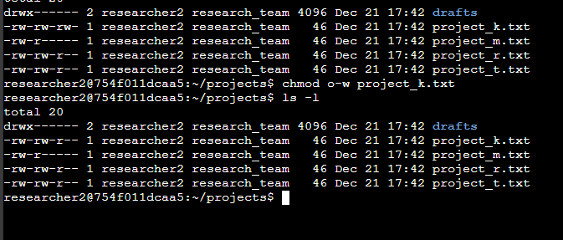
The following code demonstrates how I used Linux command to change the permissions:

This screen shot displays the before and after I put the command to remove the writing permissions for other users in Linux. The screen shot displays the commands I entered, and the other lines display the output of the second command. The chmod command changes the permissions on the files and directories. The first argument indicates what permissions should be changed and the second argument specifies the file or directory. In this example, I removed write permissions from other for the .project_k.txt file and then after I used the ls –la command to review the updates I had made.

Change file permissions on hidden file
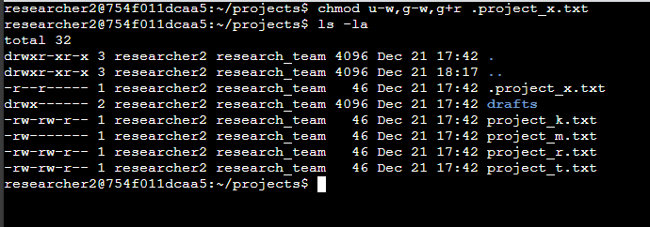
The research team at my organisation recently archived project_x.txt. They didn’t want anybody to have access to this project, however they granted read access to both the group and user. The following code demonstrates how I used Linux commands to change the permissions:
The first two lines of the screen shot display the commands I entered and the other lines display the output of the second command, I know project_x.txt is a hidden file because it starts with a period (.). In the screen shot I removed the permissions from the user and the group and added read permissions to the group. I entered the command in Linux chmod u-w,g-w which removed the writing permissions from the user and group in the hidden file. I then entered the command g+r which added the read permissions to the group in the hidden file.

Change directory permissions
My organisation onlyn wants the researcher2 user to have access to the drafts directory and its contents meaning noone else besides researcher2 user should have execute permissions.
The following code demostartes how I have used the linux commands to change permissions: 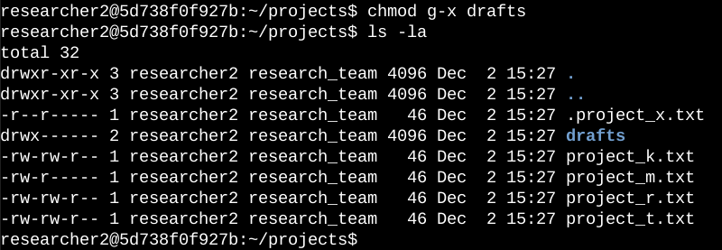
The first two lines of the screen shot display commands chmod g-x drafts that I entered which removed the execute permissions from the group and then I entered the ls –la command to make sure that the execute permissions were removed from the group. The researcher2 user already had the execute permissions so they didn’t need to be added.
Summary
I changed multiple permissions to match the level of authorisation my organisation wanted for files and directories in the projects directory. The first step was using the ls –la to check permissions for the directory. This informed my decisions in the following steps. I then used the chmod command multiple times to change the permissions on files and directories.

